**Parity predicts biological age acceleration but only in postmenopausal women:**

**Evidence from NHANES 1999-2010**

Talia N. Shirazia*, Waylon J. Hastingsb, Asher Y. Rosingera,b, Calen P. Ryanc

a Department of Anthropology, Pennsylvania State University, University Park, PA, USA

b Department of Biobehavioral Health, Pennsylvania State University, University Park, PA, USA

c Department of Anthropology, Northwestern University, Evanston, IL, USA

Running title: Parity and biological age

* Corresponding author

Department of Anthropology

421 Carpenter Building

University Park, PA 16802

talia.shirazi@gmail.com

**Abstract**

Understanding factors contributing to variation in ‘biological age’ is essential to understanding variation in susceptibility to disease and functional decline. One factor that could accelerate biological aging in women is reproduction. Pregnancy is characterized by extensive, energetically costly changes across numerous physiological systems. These ‘costs of reproduction’ may accumulate with each pregnancy, accelerating biological aging. Despite evidence for costs of reproduction using molecular and demographic measures, it is unknown whether parity is linked to commonly-used clinical measures of biological aging. We use data collected between 1999-2010 from the National Health and Nutrition Examination Survey *(n*=4,418) to test whether parity (number of live births) predicted four previously-validated composite measures of biological age and system integrity: Levine Method, homeostatic dysregulation, Klemera-Doubal method biological age, and allostatic load. Parity exhibited a U-shaped relationship with accelerated biological aging when controlling for chronological age, lifestyle, health-related, and demographic factors in postmenopausal, but not premenopausal, women, with biological age acceleration being lowest among postmenopausal women reporting between two and three live births. Our findings suggest a link between reproductive function and physiological dysregulation, and of compensatory mechanisms that buffer the effects of reproductive function on physiological dysregulation during a woman’s reproductive lifespan. Future work should continue to investigate links between parity, menopausal status, and biological age using targeted physiological measures and longitudinal studies.

*Keywords:* biological age; parity; National Health and Nutrition Examination Survey; costs of reproduction; allostatic load

**1. Introduction**

Chronological age is a leading predictor of mortality, morbidity, and functional decline 1,2. Despite the striking association between chronological age, lifespan, and health, individuals vary considerably in their rate of functional decline 3. This variation - attributed to differences in the biological rate of deterioration or repair - is referred to as ‘biological age’, and is thought to reflect the cumulative effect of environmental exposures in combination with underlying genetic variation. Various proximate mechanisms have been proposed to modulate biological age acceleration, including insulin signaling 4, oxidative stress 5, inflammation 6, epigenetic changes 7, and telomere shortening 8. Understanding the environmental, behavioral, and physiological factors that influence biological aging may inform policies and interventions that could help to mitigate their effects, thereby extending the healthspan. Such policies and interventions will become increasingly important as the proportion of the global population over age 60 is expected to increase dramatically over the next 30 years 9.

Environmental factors found to accelerate biological aging and functional decline include smoking 10, obesity 10, socioeconomic status 11, and psychosocial stress 12. Another lifestyle factor that may accelerate biological aging in women specifically is reproduction 13,14. Reproduction in women is an energetically costly process, and is characterized by extensive changes in both form and function across numerous anatomical and physiological systems 15. Pregnancy and breastfeeding are accompanied by shifts in immune function 16–18, energy metabolism and storage 19,20, blood pressure and volume 21,22, and hormone levels and receptor expression 23. Evolutionary theory predicts that these changes should create functional or energetic constraints to somatic maintenance and defense, leading to accelerated biological age - a tradeoff referred to as ‘costs of reproduction’ 24,25.

Consistent with costs of reproduction in women, ever-parity has been linked to mortality from diabetes, cancer of the uterine cervix, gallbladder disease, kidney disease, hypertension, and all-cause mortality 26–29. Similarly, women who give birth to more children are at higher risk of developing obesity, diabetes, hypertension and cardiovascular disease (CVD) 30,31, as well as age-corrected all-cause mortality 28,32,33, mortality related to cardiovascular disease 34 and mortality related to kidney disease 35. It is important to note that in the studies with the largest sample sizes (and presumably, the highest statistical power), parity exhibits a U-shaped association with all-cause mortality 32,33 and CVD 34, with highest levels of all-cause mortality and cardiovascular disease observed at lower and higher levels of parity, as compared to what is observed at intermediate levels. The number of children or pregnancies has also been linked to multiple measures of cellular aging, including DNA damage and oxidative stress 36, telomere length 13,14, and DNA methylation age 14,37. While most of these studies examine associations within Western populations, some evidence supporting costs of reproduction is seen in non-Western populations as well 14,36.

Cellular measures of biological age such as telomere length and DNA methylation age may provide insights into the molecular processes linking reproduction to mortality and other health outcomes 7,38, and may eventually serve as early indicators of the costs of reproduction in health and aging. However, ‘aging’ may refer to a wide range of processes that may occur at different times or at different speeds. For example, cellular measures of biological age that examine mitotic (e.g., telomere length) and non-mitotic (e.g., DNA methylation age) processes are not correlated 14. Similarly, both telomere length and DNA methylation age show no association with measures of biological age implemented at the clinical level 3940,41. Thus, it has been suggested that different measures of biological age and cumulative system dysregulation index fundamentally different components of the aging process.

Clinical measures of biological age quantify changes in physiological integrity by combining information from multiple clinical biomarkers that collectively assess the functioning of major organ systems throughout the body. Four composites of system integrity have been used to operationalize biological age and cumulative system dysregulation within the context of large-scale epidemiological studies in the United States: Homeostatic Dysregulation (HD) 42, Levine Method Biological Age (LM) 43,44, the Klemera-Doubal Method Biological Age (KDM) 43,45, and allostatic load (AL) 46. Previous work using a nationally representative sample of adults in the US from the National Health and Nutrition Examination Survey has found that HD, LM, KDM, and AL exhibit robust associations with physical functioning, cognition, hearing and vision, and with self-reports of health and functional disability 11,47. Other population-based studies have found similar links between AL and both objective and subjective markers of physical functioning and general health. Importantly, the energetic trade-offs between somatic maintenance and reproduction have been suggested to operate at the system level via the activity of hormones on the hypothalamic-pituitary-gonadal (HPG) axis48. Biological aging measures implemented at the cellular level may be inadequate to capture such system level dysregulation. What is unknown is whether it is possible to capture costs of reproduction in women using more easily measured, widely-used clinical measures of biological age. As they each index different yet equally important aspects of aging from cellular measures, careful study using a range of such measures is required for a more complete understanding of costs of reproduction in women.

Here, we present nationally-representative estimates of the effect of parity (operationalized as number of live births) on four composites of system integrity indexing biological age and cumulative dysregulation. Using cross-sectional epidemiological data collected in the United States between 1999 and 2010, we test whether parity is associated with HD, KDM, LM, and AL while controlling for a range of covariates (e.g., smoking, obesity) known to modulate biological age to better isolate the unique contribution of parity on biological age. Although each measure utilizes the same panel of biomarkers, differences in scale construction provide a varied, multifactorial approach to the study of costs of reproduction on biological aging. Based on findings from the most highly powered prior studies of all-cause mortality and parity, we hypothesized a U-shaped relationship between parity and biological aging; specifically, that accelerated biological aging would be most apparent in women with the lowest and the highest parity. We also perform exploratory analyses to test whether relationships between parity and biological age are chronic, such that they persist regardless of time since last birth, or acute, such that the effect of parity on biological age decreases as a function of time since last birth. Our findings have significant theoretical implications for our understanding of the relationship between parity and health, and of putative tradeoffs between reproductive and somatic effort.

**2. Materials and Methods**

*Data source*

Data were collected as part of the Centers for Disease Control and Prevention’s National Health and Nutrition Examination Survey (NHANES). NHANES uses multistep cluster sampling, and assigns participants sample weights based on demographic variables such as self-identified race/ethnicity, age, and education; utilization of these sample weights in analyses enables estimation of population-level effects. Continuous sampling for NHANES began in 1999, and data is made publicly available in two-year waves. Details of recruitment procedures and study design are available from the Centers for Disease Control and Prevention 49. Women sampled between 1999 and 2010 are included in the present analyses, as not all the data necessary to construct the biological aging measures (i.e. C-reactive protein) were released for cycles following the 2009-2010 cycle at the time of writing this manuscript. Furthermore, women missing information on any covariate included in analyses were excluded from the sample. A flowchart detailing sample stratification can be found in **Figure 1**, and sample demographic information is presented in **Table 1**.

To assess the representativeness of participants with complete biomarker information, we compared the subset of non-pregnant women aged 18-84 with complete biomarker data (*n* = 5,870) to all non-pregnant women aged 18-84 in NHANES 1999-2010 (*n* = 13,929). The two samples were similar in age, ethnicity, educational attainment, income, smoking status, menopausal status, and number of live births. However, the sample with complete biomarker data was significantly more likely to have ever been pregnant. Comparative demographics and associated tests of difference are reported in **ESM Table I**.

*Ethical approval*

All sampling procedures were approved through the National Center for Health Statistics Ethics Review Board, and all participants provide informed consent before sample collection and interviews.

*Reproductive health and parity data*

Women completed a computer-assisted questionnaire on their reproductive health history. Women reported whether they were currently pregnant, if they have ever been pregnant, how many pregnancies resulted in a live birth (if applicable; NHANES items RHD170 and RHQ171), whether they had regular periods over the last 12 months, and their reason for not having regular periods over the last 12 months (if applicable). As previous work has suggested that current pregnancy modulates certain measures of biological age 14, women who self-reported currently being pregnant were excluded from analyses (NHANES item RIDEXPRG; n = 1,417 out of all women between 18 and 84). Due to the small number of women with complete covariate information who reported 7 or more live births (n = 137), these women were excluded from analyses. The frequency distribution for women included in our analyses is displayed in **Figure 2**. We chose to use number of live births rather than number of pregnancies. NHANES does not collect fine-grained data about pregnancies that do not result in live births, rendering it impossible to estimate the length of each pregnancy, and concomitantly, the physiological cost of each pregnancy. Further, approximately 30% of implantations end in natural miscarriage 50, making number of recognized pregnancies a more imprecise measure of physiological investment in reproduction as compared to number of live births. Women who reported a prior live birth indicated their age at last live birth across all survey cycles. Because responses to this question were bottom-coded at 14 and top-coded at 45 for some cycles, we limited our analysis to women who reported an age of last live birth between 15 and 44. Starting in the 2007-2008 cycle, NHANES added a question on the number of months since last live birth for women who reported up to a two year difference between their current age and age of last birth.

Women were categorized as being pre-menopausal if they reported having regular periods over the last 12 months, if they reported not having regular periods because of a reason other than menopause, or if they were younger than 41. A lower limit of 41 was chosen because the average age of menopause in the US is 51, and perimenopause may last up to 10 years for some women 51. Women were categorized as being post-menopausal if they were older than 61, or if they reported not having regular periods over the last 12 months because of menopause.

*Biological aging measures*

All composite measures of biological aging were constructed using the following 9 biomarkers: albumin, creatinine, glucose, log-transformed C-reactive protein (CRP), lymphocyte percent, mean cell volume, red blood cell distribution width, alkaline phosphatase, and white blood cell count. Where appropriate, female participants from NHANES III, for which data collection ran between 1988 and 1994, were used as the reference sample for the construction of the biological aging measures employed here. Serum creatinine values from NHANES III and NHANES 1999-2004 continuous panels were adjusted according to published recommendations 52.

Homeostatic Dysregulation (HD) is a measure of Mahalanobis distance 53, quantifying the deviation of a participant’s physiology from a young, healthy reference norm. Following previous work 11, we defined our reference population as non-pregnant women from NHANES III aged 20-30 who were not obese (BMI<30) and for whom all biomarkers fell within the clinically normal range for their age and sex (N = 481, see **ESM Tables II-IV**)**.** Biomarker values from the reference population were standardized and used to compute a biomarker variance-covariance matrix (**ESM Table IV**). Biomarker raw means, raw standard deviations, and the standardized-biomarker variance-covariance matrix are implemented within the Mahalanobis distance equation 53 to form the homeostatic dysregulation (HD) algorithm: . Here, *v* is a vector of biomarker values for a participant in the analysis sample; *u* is a vector of biomarker means in the training sample, and *S*is the standardized-biomarker variance-covariance matrix. As HD in the full sample was significantly skewed, natural log-transformed HD was used as the outcome variable in all analyses.

Klemera-Doubal Method (KDM) Biological Age is computed using the Klemera-Doubal equation 45, which extracts information from individual regressions of chronological age onto *m* biomarkers: $KDM=\frac{\sum_{j=1}^{m}{\left(x_{j}-q_{j}\right)\frac{k_{j}}{s_{j}^{2}}+\frac{CA}{s_{BA}^{2}}}}{\sum_{j=1}^{m}{{\left(\frac{k_{j}}{s_{j}}\right)}^{2}+\frac{1}{s_{BA}^{2}}}}$. Here, *xj* is the value of biomarker *j* measured for an individual in the analytical sample and *CA* is their chronological age. For each biomarker *j*, the parameters *q* (intercept), *k* (slope), and *s* (root mean squared error) are estimated from a regression of chronological age onto the biomarker in the reference population. *sBA* is a scaling factor equal to the square root of the variance in chronological age explained by the biomarker panel in the reference population 43 (Eq. 5). Following previous work 43, we formed our reference population from non-pregnant women in NHANES III aged 30-75 (N = 5,453, see **ESM Tables V and VI**). An individual's KDM Biological Age corresponds to the average chronological age at which their physiology would be observed in

the reference population.

Levine Method (LM) Biological Age is computed from a multivariate analysis of mortality hazards using NHANES III data 43,44. Herein, a multivariate Gompertz model of mortality hazard is fit to the selected biomarkers and chronological age to form a predicted hazard of mortality called a “mortality score”. This mortality score is converted to a biological age value using a second univariate Gompertz regression of the mortality hazard onto chronological age. In this manner, the LM biological age is interpretable as the chronological age at which an individual’s physiology-based risk for mortality would be approximately normal in the reference population. We applied published parameters from Liu and colleagues’ original work 44 to compute LM biological age for participants in our sample.

Allostatic Load (AL) is computed as the proportion of biomarker values for which a participant is at risk. In accordance with recommendations from a review of AL implementation in NHANES 54, we defined risk as residing within the highest quartile of a given biomarker’s distribution within the sample of nonpregnant women aged 18-84 with complete biological age biomarker data, excepting albumin for which risk was defined as residing in the lowest quartile (N = 5,870; **ESM Table VII**). In this manner, the number of biomarkers for which a participant is at risk is divided by the total number of biomarkers in the panel to calculate a final allostatic load score with values ranging from 0-1.

All four biological aging measures were computed using the same panel of 9 biomarkers. These biomarkers were selected based upon their inclusion in the LM biological age algorithm, which utilized machine-learning analysis to select the most parsimonious panel of biomarkers for mortality prediction. The use of common biomarkers ensures the different measures are indexing the same physiological processes. Differences in the analytical approach and statistical operations leading to the final composite measure reflects different approaches toward the conceptualization of biological age. For HD, biological age is conceptualized as deviation from an ideal physiological state attained in one’s 20s. For KDM, biological age is conceptualized as the average change in physiology that occurs with increasing chronological age. Building upon this, LM captures the increased risk in mortality that accompanies physiological changes occurring with age. Finally, AL conceptualizes aging as the accumulation of changes that become impactful only once they reach a critical threshold. Biomarker and biological age summary statistics for the final analytical sample (*n* = 4,418) are provided in **ESM Table VIII.**

Univariate distributions, bivariate distributions, and Pearson correlations coefficients for age, LM, log-transformed HD, and KDM are displayed in **Figure 3**. Expectedly, all four measures of biological age were significantly correlated with chronological age, and all four measures of biological age were significantly correlated with each other.

*Covariates*

Self-reported race/ethnicity 55, socioeconomic status (SES) 56,57, and smoking 10 moderate the relationship between chronological age and biological aging. Self-reported race/ethnicity was categorized as non-Hispanic (NH) white, NH black, Hispanic, and ‘other’ (NHANES item RIDRETH1). SES was indexed by educational attainment (NHANES item DMDEDUC2) and federal income-to-poverty ratio (FIPR; NHANES item INDFMPIR as calculated per Department of Health and Human Services guidelines). Height and weight were measured by an NHANES examiner, and BMI was calculated as weight (kg) divided by height (meters squared; NHANES item BMXBMI). As prior work has shown that BMI exhibits a U-shaped curve with negative health outcomes 58, our models included both linear and quadratic terms for BMI. On the basis of responses to a computer-assisted questionnaire on smoking habits, women were classified as never, past, or current smokers. To better isolate the effect of parity and biological age, our primary models controlled for the aforementioned covariates.

*Statistical analyses*

All analyses were performed in R using the *survey* package, which supports functionality for analyzing data from complex survey designs. To facilitate accessibility of our methods, we also performed all analyses in Stata version 16.1. R scripts, Stata scripts, and data files have been uploaded online and can be found at <https://osf.io/b2jft/>.

We followed all NHCS guidelines for the analysis of NHANES data 59. As the survey weights relevant to the smallest sample subpopulation for which all data are available should be used, we used mobile examination center (MEC) weights to adjust for complex survey design, oversampling, non-coverage, day of the week, and survey nonresponse to compute nationally representative estimates 60,61. Per NHANES analytical guidelines for combining data across cycles, 12-year MEC weights were calculated using the NHANES-provided variables WTMEC4YR and WTMEC2YR as follows: $$WTMEC12YR=\frac{1}{3}*WTMEC4YR for the 1999-2000 and 2001-2002 cycles$$

$$WTMEC12YR=\frac{1}{6}*WTMEC2YR for all subsequent cycles.$$

Because we estimated four regressions (one per outcome measure) for each set of analyses for each analytical subset, statistical significance was set to *p* < 0.0125 (0.05/4) 62.

We estimated multiple linear regression models to examine the association of number of live births on biological age when controlling for chronological age, self-reported race/ethnicity, educational attainment, FIPR, BMI, and smoking. To focus on biological aging, we conducted analyses using versions of each biological age measure after adjustment for chronological age, computed as the residuals of each measure regressed onto chronological age. Following adjustment, biological aging measures were no longer correlated with chronological age (**ESM Table IX**). Separate models were estimated for LM, log-transformed HD, KDM, and AL.

We estimated both linear and quadratic terms for number of live births, as it has been previously suggested that the number of live births may exert quadratic, rather than linear, effects on morbidity and mortality 32–34. As higher values correspond to more advanced biological age across all biological aging measures, a positive linear effect suggests a higher number of live births is associated with a higher biological age. A positive quadratic effect would suggest a convex (or U-shaped) shape to the fitted curve, while a negative quadratic effect would suggest a concave shape to the fitted curve. As prior work suggests that costs of reproduction should be the most apparent after menopause 48,63, models were estimated separately premenopausal and postmenopausal women. Equations for each regression are provided in **ESM Text 1**.

Figure 4 was generated using Stata through post-estimation marginal standardization postestimation commands in Stata for regressions adjusting for the distribution of other covariates 64. The y-axes in these figures represent the extent to which chronological age deviates from biological age. For each measure, this presents the difference between observed biological age and biological age predicted by chronological age (i.e., the residual of each biological aging measure regressed onto the chronological age). In all four cases, positive values indicate aging acceleration (biological age > chronological age) while negative values indicate age deceleration (biological age < chronological age).

*Sensitivity analyses*

We conducted a series of follow-up regressions to probe the robustness of our primary analyses. First, we repeated the multiple linear regressions exactly as described above, including only chronological age as a covariate. This was done to ensure the relationship between variables included in our primary analyses and biological age were so strong as to masking putative relationships between parity and biological age. For example, in our sample BMI was significantly, positively correlated with LM and KDM (*r* = 0.29 and 0.28, respectively; *p* < 0.001).

We then estimated a second and third set of sensitivity analyses, with time since last birth used to create additional model terms. We chose these as sensitivity analyses rather than primary analyses for two reasons. First, models including time since last birth by default eliminate all nulliparous women, rendering us unable to calculate estimates for the effect of parity for nulliparous women. Second, data on time since last birth were missing for a significant portion of our sample. In these models, we assessed the extent to which effects of parity may be chronic and accumulate over time, or acute and only present in the postnatal period. To assess potential chronic effects, years since last birth was calculated for women across all survey cycles as age of last live birth subtracted from current chronological age. To assess potential acute effects data on months since last birth was available for women sampled in the 2007-2008 and 2009-2010 cycles. We estimated one set of regressions exactly as described above for our primary analyses, and added terms for the main effect of years since last birth and interactions between years since last birth and parity (sensitivity analysis 2). We then estimated additional set of regressions exactly as described above for our primary analyses and added terms for the main effect of months since last birth and interactions between months since last birth and parity (sensitivity analysis 3); however, this analysis was conducted in premenopausal women only since data on months since last birth were not available for any postmenopausal women,.

**3. Results**

*Differences between premenopausal and postmenopausal women*

Demographic differences and differences in biological age acceleration are presented in Table 1. [ Have to repeat analyses using survey-adjusted methods for all variables except for the biological age variables, which have already been analyzed using survey-adjusted regressions ]. When adjusting for demographic differences, premenopausal women exhibited significantly lower LM and KDM biological age acceleration relative to postmenopausal women.

*Premenopausal women*

The linear effect of number of live births and squared term, or quadratic effect, of live births was not significant in any primary model in premenopausal women (*n* = 2,166; see **Table 2; Figure 4**). Sample sizes for our sensitivity analyses controlling for chronological age only were slightly larger (*n* = 2,686), as less participants were excluded due to missing covariate information. Similar to our primary analyses, the main effects of live births (both linear and quadratic terms) were not significant across all measures of biological age (**Table 2**). Of the 2,166 premenopausal women in our primary analyses, data on years since last live birth were available for 1,617. The average years since last live birth was 8.87 (SE = 0.19). After correcting for multiple comparisons, the main effect of years since last live birth was not significant in any model, nor were any of the interaction terms between years since last live birth and parity (**Table 2**).

Our sample size for analyses including months since last live birth (*n* = 107) was significantly limited by the fact that this subsample excluded all postmenopausal women, and excluded women sampled prior to this question being added in the 2007-2008 cycle. Because of this limited sample size, these results should be interpreted as exploratory only. On average, women with valid responses to this question gave birth 10.7 months ago (SE = 0.63). After correcting for multiple comparisons, the main effects of months since last live birth and parity was not significant in any model, nor were any of the interaction terms between months since last live birth and parity (**Table 2**).

*Postmenopausal women*

Primary models in postmenopausal women revealed a significant linear effect of live births on biological aging indexed by LM, HD, and AL; the linear effect of live births on KDM was not significant after correction for multiple comparisons (*n* = 2,252; **Table 3**). After correcting for multiple comparisons, the quadratic effect of parity on biological aging was significant for all measures but KDM. Sample sizes for our sensitivity analyses controlling for chronological age only were slightly larger (*n* = 2,498). Similar trends were observed in the first set of sensitivity analyses, wherein the linear effect of live births was significantly associated with LM, HD, and AL. Moreover, the quadratic effect was significant for all four measures, giving rise to the anticipated U-shape for the overall relationship between parity and biological aging (shown in grey on **Figure 4**). Of the 2,252 postmenopausal women in our primary analyses, data on years since last birth were available for 1,970. The average years since last birth was 36.09 (SE = 0.25). After correcting for multiple comparisons, the main effect of years since last live birth was not significant in any model, nor were any of the interaction terms between years since last live birth and parity (**Table 3**).

**4. Discussion**

Our primary aim was to examine putative physiological costs of reproduction, as indexed by four validated measures of biological age and system integrity among a nationally-representative sample of US women of reproductive and post-reproductive age. Based on results of prior work, we hypothesized a U-shaped relationship between parity and biological age. When controlling for lifestyle, health-related, and demographic factors, the main effect of parity (defined as number of live births) was not significantly associated biological aging among premenopausal women. By contrast, analyses in postmenopausal women revealed the hypothesized U-shape relationship between parity and biological age, with biological age acceleration reaching a minimum at 2-3 live births and more pronounced aging at either extreme. Notably, this pattern was observed for all four measures, although effects did not remain significant for KDM after controlling for multiple comparisons. To our knowledge, our study represents the first application of biological age composites indexing system integrity (LM, HD, KDM, AL) to quantify costs of reproduction in both pre- and postmenopausal women. In what follows, we situate our results in what we view as the most tenable hypotheses relating parity to physiological dysregulation and biological aging.

According to the reproductive-cell cycle theory of aging, the protective forces acting to ensure survival during the reproductive stage of the lifespan are diminished in the post-menopausal period48. Changes in hypothalamic-pituitary-gonadal (HPG) axis function associated with menopause are proposed as the proximate causes of the increased physiological dysregulation observed in women after they are no longer in their reproductive stage. It is hypothesized that the combination of higher levels of hypothalamic and pituitary hormones, coupled with decreases in ovarian hormone production, together contribute to cell-cycle changes that then manifest as morbidity and mortality. Epidemiological and experimental lines of evidence support this hypothesis. Women who experience later menopause are at lower risk of cardiovascular disease, osteoporosis, and cognitive decline 65. Premenopausal women who undergo an oophorectomy (surgical removal of one or both ovaries) are at higher risk of these same outcomes66,67, suggesting the role of HPG axis outputs in modulating these age-related phenotypes. Experimental work manipulating ovarian hormone levels in animal models and observations of women taking hormone replacement therapy also find less age-related decline in hormonal milieus more closely approximating that of the reproductive stage (reviewed in 48).

Several findings in the present study support the reproductive-cell cycle theory of aging. First is our main finding that links between parity and accelerated biological aging were apparent in only postmenopausal women (see also 63). Second, years since last live birth did not significantly predict biological age acceleration in either pre- or postmenopausal women, nor did months since last live birth among premenopausal women, suggesting that any putative links between biological age and parity are not due to short-term physiological changes associated with pregnancy and breastfeeding. Third, biological age acceleration was significantly higher in postmenopausal as compared to premenopausal women, as has been reported previously68.

Our findings are thus most consistent with an effect between parity and biological aging acceleration that is buffered by premenopausal HPG axis function, and perhaps by other compensatory mechanisms, that cease to function in women’s post-reproductive years. Due to the nature of the data analyzed here, we cannot form specific hypotheses on the precise nature of these mechanisms, and existing data remains inconclusive. For example, the telomerase enzyme involved in protecting telomere integrity is activated by estrogen 69. However, epidemiological studies have observed slower rates of telomere attrition in the years following menopause 70. [ insert one or two more examples suggesting link between HPG axis hormones and changes in system or cellular function – maybe BBB permeability stuff? ] Thus, it remains unclear how changes in ovarian hormones associated with menopause contribute to cellular instability and aging.

*Limitations*

The fact that NHANES is cross-sectional rather than longitudinal in design contributes to two significant limitations in our study. First, its cross-sectional nature does not allow us to draw conclusions about causal relationships (or lack thereof); thus, it is crucial that future work follow women as they transition from nulliparity to parity, and as they continue to reproduce, to best evaluate causal relationships between reproduction and biological age. However, should a causal relationship between chronic effects of parity and biological age exist among premenopausal women, this should have been apparent in our cross-sectional data, especially given the low levels of error or bias in reporting the number of live births. Second, we are only able to examine relatively chronic, rather than acute, effects of reproduction on biological age given the current study design. Though our analyses do not support acute effects of reproduction on biological age acceleration, longitudinal studies, ideally with dense sampling schedules, would better enable us to assess the time scales at which costs of reproduction may be apparent. Frequently sampling women during both their reproductive and post-reproductive years would allow for the investigation of putative acute and chronic changes in markers and composites of biological age. In the absence of dense longitudinal sampling, we cannot be certain that biomarkers measured in this cross-sectional sample are not also representative of acute states unrelated to parity or reproduction. For example, it is possible that some participants could have been experiencing mild infections during MEC examinations, leading to altered clinical measures of immune function. Though this could contribute to imprecision in our biological aging measures, such imprecision would not be systematic and thus we would not expect it to significantly affect the present study’s findings. Women’s prenatal health also predicts both pregnancy outcomes 71,72, as well as postnatal health risks. As such, longitudinal studies are necessary to understand what factors moderate reproduction-related changes in biological age across women.

Another limitation is that BMI is an important contributor to observed differences in biological age 73. We observed no significant differences in BMI as a function of menopausal status in our sample, which diminishes the likelihood that the association between parity and biological aging in postmenopausal women is driven by differences in body composition. Even so, changes in body mass and adiposity are central to the physiological changes occurring with pregnancy as women begin “metabolizing for two” 74. Parity is associated with increased central adiposity 75, and pregnancy-related weight gain can mediate associations between obesity and long-term morbidity 76. These risks might be reduced by breast-feeding, which acts to mobilize accumulated fat and reset maternal metabolism 77. As NHANES does not include fine-grained data on lactation practices, we were unable to examine the additive effects of parity and lactation on biological age. Both cross-sectional and longitudinal future studies should aim to more fully quantify pre- and post-natal factors indexing reproduction-related energetic investment.

Should HPG axis hormones modulate cellular processes that then affect clinical measures used to create biological age composites, we would hypothesize that current hormone use (whether in the form of hormonal contraceptives in premenopausal women, or hormone replacement therapy in postmenopausal women) would affect biological age and should thus be examined as a predictor. Indeed, long-term hormone replacement therapy has been associated with increased telomere length in post-menopausal women78. Though NHANES collects data on lifetime patterns of hormonal contraceptive and hormone replacement therapy, it does not collect data on *current* use. Future studies assessing the feasibility of HPG axis outputs as modulators of biological age acceleration should thus consider effects of current hormone-altering medication use.

Finally, because data were collected in the United States, it is unknown whether similar patterns would be observed outside the context of WEIRD (Western, Educated, Industrialized, Rich, and Democratic) 79 samples. WEIRD and non-WEIRD countries are characterized by significantly different activity patterns, nutrition, infectious disease ecology, and morbidity and mortality 80, all of which could shape how reproduction affects women’s health and hence, costs of reproduction. Non-WEIRD countries are also characterized by higher parity 81. It is possible that the parity in our sample was too restricted in range to detect extant parity-biological age associations, and based on our sample, we cannot make estimations about the nature of these associations in women who report more than seven previous live births. Whereas some studies have indeed examined links between parity and aging in non-Western settings 14,82, more research is necessary to better catalogue and understand cross-cultural variation in costs of reproduction in women.

*Conclusions*

We analyzed links between parity and different measures of biological aging using a large, nationally-representative epidemiological sample of pre- and post-menopausal women in the United States. Our results suggest that parity is associated with accelerated biological age in postmenopausal but not premenopausal women, and that hormone-driven compensatory mechanisms may buffer against physiological dysregulation caused by reproduction in premenopausal women. Future work should identify the putative compensatory mechanisms present in premenopausal women that mitigate biological age acceleration. Future work should also employ longitudinal designs and collect more detailed data on variables quantifying energetic investment in reproduction to more fully elucidate costs of reproduction and the time scales in which they are apparent.

**References**

1. Kennedy, B. K. *et al.* Geroscience: linking aging to chronic disease. *Cell* **159**, 709–713 (2014).

2. Kirkwood, T. B. Understanding the odd science of aging. *Cell* **120**, 437–447 (2005).

3. Levine, M. E. & Crimmins, E. M. Is 60 the New 50? Examining Changes in Biological Age Over the Past Two Decades. *Demography* **55**, 387–402 (2018).

4. Kaletsky, R. & Murphy, C. T. The role of insulin/IGF-like signaling in C. elegans longevity and aging. *DMM Dis. Model. Mech.* **3**, 415–419 (2010).

5. Shigenaga, M. K., Hagen, T. M. & Ames, B. N. Oxidative damage and mitochondrial decay in aging. *Proc. Natl. Acad. Sci. U. S. A.* **91**, 10771–10778 (1994).

6. Franceschi, C. & Campisi, J. Chronic inflammation (Inflammaging) and its potential contribution to age-associated diseases. *Journals Gerontol. - Ser. A Biol. Sci. Med. Sci.* **69**, S4–S9 (2014).

7. Horvath, S. & Raj, K. DNA methylation-based biomarkers and the epigenetic clock theory of ageing. *Nat Rev Genet* **19**, 371–384 (2018).

8. Sanders, J. L. & Newman, A. B. Telomere length in epidemiology: A biomarker of aging, age-related disease, both, or neither? *Epidemiol. Rev.* **35**, 112–131 (2013).

9. United Nations. *World Population Prospects 2019*. *Department of Economic and Social Affairs. World Population Prospects 2019.* (2019).

10. Valdes, A, M. *et al.* Obesity, cigarette smoking, and telomere length in women. *Lancet* **366**, 662–664 (2005).

11. Hastings, W. J., Shalev, I. & Belsky, D. W. Comparability of biological aging measures in the National Health and Nutrition Examination Study, 1999-2002. *Psychoneuroendocrinology* **106**, 171–178 (2019).

12. Epel, E. S. *et al.* Accelerated telomere shortening in response to life stress. *Proc. Natl. Acad. Sci.* **101**, 17312–17315 (2004).

13. Pollack, A. Z., Rivers, K. & Ahrens, K. A. Parity associated with telomere length among US reproductive age women. *Hum. Reprod.* **33**, 736–744 (2018).

14. Ryan, C. P. *et al.* Reproduction predicts shorter telomeres and epigenetic age acceleration among young adult women. *Sci. Rep.* 1–9 (2018). doi:10.1038/s41598-018-29486-4

15. Tan, E. K. & Tan, E. L. Alterations in physiology and anatomy during pregnancy. *Best Pract. Res. Clin. Obstet. Gynaecol.* **27**, 791–802 (2013).

16. Cramer, D. W. & Vitonis, A. F. Signatures of reproductive events on blood counts and biomarkers of inflammation: Implications for chronic disease risk. *PLoS One* **12**, 1–19 (2017).

17. Lurie, S., Rahamim, E., Piper, I., Golan, A. & Sadan, O. Total and differential leukocyte counts percentiles in normal pregnancy. *Eur. J. Obs. Gynecol. Reprod. Biol.* **136**, 16–19 (2008).

18. Faas, M. M., Spaans, F. & De Vos, P. Monocytes and macrophages in pregnancy and pre-eclampsia. *Front. Immunol.* **5**, 1–11 (2014).

19. Soma-Pillay, P., Nelson-piercy, C., Tolppanen, H. & Mebazaa, A. Physiological changes in pregnancy. *Cardiovasc. J. Afr.* **27**, 89–94 (2016).

20. Fried, R. L., Mayol, N. L., McDade, T. W. & Kuzawa, C. W. Maternal metabolic adaptations to pregnancy among young women in Cebu, Philippines. *Am. J. Hum. Biol.* **29**, e23011 (2017).

21. Sanghavi, M. & Rutherford, J. D. Cardiovascular physiology of pregnancy. *Circulation* **130**, 1003–1008 (2014).

22. Cheung, K. L. & Lafayette, R. A. Renal physiology of pregnancy. *Adv. Chronic Kidney Dis.* **20**, 209–214 (2013).

23. Kovacs, C. S. & Deal, C. *Maternal-Fetal and Neonatal Endocrinology: Physiology, Pathophysiology, and Clinical Management*. (Academic Press, 2019).

24. Harshman, L. G. & Zera, A. J. The cost of reproduction: The devil in the details. *Trends Ecol. Evol.* **22**, 80–86 (2006).

25. Jasienska, G. Costs of reproduction and ageing in the human female. *Philos. Trans. R. Soc. B Biol. Sci.* **375**, 20190615 (2020).

26. Beral, V. & Beral, V. Long term effects of childbearing. *J. Epidemiol. Community Health* **39**, 343–346 (1985).

27. Grundy, E. Women’s Fertility and Mortality in Late Mid Life: A Comparison of Three Contemporary Populations. *Am. J. Hum. Biol.* **547**, 541–547 (2009).

28. Lund, E. Number of children and death from hormone-dependent cancers. *Int. J. Cancer* **46**, 998–1000 (1990).

29. Hurt, L. S. *et al.* The effect of number of births on women’s mortality: Systematic review of the evidence for women who have completed their childbearing. *Popul. Stud. (NY).* **60**, 55–71 (2006).

30. Lawlor, D. A. *et al.* Is the association between parity and coronary heart disease due to biological effects of pregnancy or adverse lifestyle risk factors associated with child-rearing? Findings from the British Women’s Heart and Health Study and the British Regional Heart St. *Circulation* **107**, 1260–1264 (2003).

31. Simons, L. A., Simons, J., Friedlander, Y. & McCallum, J. Childbearing history and late-life mortality: The Dubbo study of Australian elderly. *Age Ageing* **41**, 523–528 (2012).

32. Zeng, Y. *et al.* Parity and All-cause Mortality in Women and Men: A Dose-Response Meta-Analysis of Cohort Studies. *Sci. Rep.* **6:19351**, 1–11 (2016).

33. Dior, U. P. *et al.* Association between number of children and mortality of mothers: Results of a 37-year follow-up study. *Ann. Epidemiol.* **23**, 13–18 (2013).

34. Lv, H., Wu, H., Yin, J., Qian, J. & Ge, J. Parity and Cardiovascular Disease Mortality: a Dose-Response Meta- Analysis of Cohort Studies. *Sci. Rep.* **5:13411**, 1–9 (2015).

35. Guan, H., Wu, Q. & Gong, T. Parity and Kidney Cancer Risk: Evidence from Epidemiologic Studies. *Cancer Epidemiol. Biomarkers Prev.* **22**, 2345–2354 (2013).

36. Ziomkiewicz, A., Sancilio, A., Galbarczyk, A. & Klimek, M. Evidence for the cost of reproduction in humans: High lifetime reproductive effort is associated with greater oxidative stress in post-menopausal women. *PLoS One* **11**, 1–14 (2016).

37. Kresovich, J. K. *et al.* Reproduction, DNA methylation and biological age. *Hum. Reprod.* **34**, 1965–1973 (2019).

38. Harley, C. B., Vaziri, H., Counter, C. M. & Allsopp, R. C. The telomere hypothesis of cellular aging. *Exp Gerontol* **27**, 375–382 (1992).

39. Belsky, D. W. *et al.* Eleven Telomere, Epigenetic Clock, and Biomarker-Composite Quantifications of Biological Aging: Do They Measure the Same Thing? *Am J Epidemiol* **187**, 1220–1230 (2017).

40. McCrory, C. *et al.* Association of 4 epigenetic clocks with measures of functional health, cognition, and all-cause mortality in The Irish Longitudinal Study on Ageing (TILDA). *bioRxiv* 2020.04.27.063164 (2020). doi:10.1101/2020.04.27.063164

41. Ahrens, K. A., Rossen, L. M. & Simon, A. E. Relationship Between Mean Leucocyte Telomere Length and Measures of Allostatic Load in US Reproductive-Aged Women, NHANES 1999–2002. *Paediatr. Perinat. Epidemiol.* **30**, 325–335 (2016).

42. Cohen, A. A. *et al.* A novel statistical approach shows evidence for multi-system physiological dysregulation during aging. *Mech. Ageing Dev.* **134**, 110–117 (2013).

43. Levine, M. E. Modeling the Rate of Senescence: Can Estimated Biological Age Predict Mortality More Accurately Than Chronological Age? *Journals Gerontol. Ser. a-Biological Sci. Med. Sci.* **68**, 667–674 (2013).

44. Liu, Z. *et al.* A new aging measure captures morbidity and mortality risk across diverse subpopulations from NHANES IV: A cohort study. *PLoS Med* **15**, e1002718 (2018).

45. Klemera, P. & Doubal, S. A new approach to the concept and computation of biological age. *Mech. Ageing Dev.* **127**, 240–248 (2006).

46. McEwen, B. S. Stress, adaptation and disease: Allostatis and allostatic load. *Ann. N. Y. Acad. Sci.* **840**, 33–44 (1998).

47. Santos-Lozada, A. R. & Howard, J. T. Using allostatic load to validate self-rated health for racial/ethnic groups in the United States. *Biodemography Soc. Biol.* **64**, 1–14 (2018).

48. Atwood, C. S. & Bowen, R. L. The reproductive-cell cycle theory of aging: An update. *Exp. Gerontol.* **46**, 100–107 (2011).

49. Centers for Disease Control and Prevention, N. C. for H. S. (NCHS). National Health and Nutrition Examination Survey Data. (2018).

50. Wilcox, A. J. *et al.* Incidence of Early Loss of Pregnancy. *N. Engl. J. Med.* **319**, 189–194 (1988).

51. Lobo, R. A. *Menopause and Aging*. *Yen and Jaffe’s Reproductive Endocrinology: Seventh Edition* (Elsevier, 2013). doi:10.1016/B978-1-4557-2758-2.00015-9

52. Selvin, E. *et al.* Calibration of serum creatinine in the National Health and Nutrition Examination Surveys (NHANES) 1988-1994, 1999-2004. *Am. J. Kidney Dis.* **50**, 918–926 (2007).

53. Mahalanobis, P. C. Mahalanobis distance. *Proc. Natl. Inst. Sci. India* **49**, 234–256 (1936).

54. Duong, M. T., Bingham, B. A., Aldana, P. C., Chung, S. T. & Sumner, A. E. Variation in the calculation of allostatic load score: 21 examples from NHANES. *J. Racial Ethn. Heal. Disparities* **4**, 455–461 (2017).

55. Levine, M. E. & Crimmins, E. M. Evidence of accelerated aging among African Americans and its implications for mortality. *Soc. Sci. Med.* **118**, 27–32 (2014).

56. Steptoe, A. *et al.* Educational attainment but not measures of current socioeconomic circumstances are associated with leukocyte telomere length in healthy older men and women. *Brain. Behav. Immun.* **25**, 1292–1298 (2011).

57. Robertson, T. *et al.* Is socioeconomic status associated with biological aging as measured by telomere length? *Epidemiol. Rev.* **35**, 98–111 (2013).

58. Lewis, C. E. *et al.* Mortality, health outcomes, and body mass index in the overweight range. *Circulation* **119**, 3263–3271 (2009).

59. National Center for Health Statistics. NHANES survey methods and analytic guidelines. (2018). Available at: https://wwwn.cdc.gov/nchs/nhanes/AnalyticGuidelines.aspx. (Accessed: 4th February 2020)

60. Korn, E. L. & Graubard, B. I. *Analysis of health surveys*. (John Wiley & Sons, 1999).

61. Rosinger, A. Y. & Ice, G. Secondary data analysis to answer questions in human biology. *Am. J. Hum. Biol.* **31**, 1–19 (2019).

62. Abdi, H. The Bonferonni and Šidák Corrections for Multiple Comparisons. in *Encyclopedia of Measurement and Statistics* (ed. Salkind, N.) 1–9 (Sage, 2007). doi:10.4135/9781412952644

63. Westendorp, R. G. & Kirkwood, T. Human longevity at the cost of reproductive success. *Nature* **396**, 743–746 (1998).

64. Graubard, B. I. & Korn, E. L. Predictive margins with survey data. *Biometrics* **55**, 652–659 (1999).

65. Ossewaarde, M. E. *et al.* Age at menopause, cause-specific mortality and total life expectancy. *Epidemiology* **16**, 556–562 (2005).

66. Gleason, C. E., Cholerton, B., Carlsson, C. M., Johnson, S. C. & Asthana, S. Neuroprotective effects of female sex steroids in humans: Current controversies and future directions. *Cell. Mol. Life Sci.* **62**, 299–312 (2005).

67. Parker, W. H. *et al.* Ovarian conservation at the time of hysterectomy and long-term health outcomes in the Nurses’ Health study. *Obstet. Gynecol.* **113**, 1027–1037 (2009).

68. Levine, M. E. *et al.* Menopause accelerates biological aging. *Proc. Natl. Acad. Sci. U. S. A.* **113**, 9327–9332 (2016).

69. Kyo, S. *et al.* Estrogen activates telomerase. *Cancer Res.* **59**, 5917–5921 (1999).

70. Dalgård, C. *et al.* Leukocyte telomere length dynamics in women and men: Menopause vs age effects. *Int. J. Epidemiol.* **44**, 1688–1695 (2015).

71. Negrato, C. A., Mattar, R. & Gomes, M. B. Adverse pregnancy outcomes in women with diabetes. *Diabetol. Metab. Syndr.* **4**, 2–7 (2012).

72. Seely, E. W. & Ecker, J. Chronic hypertension in pregnancy. *Circulation* **129**, 1254–1261 (2014).

73. Müezzinler, A., Zaineddin, A. K. & Brenner, H. Body mass index and leukocyte telomere length in adults: A systematic review and meta-analysis. *Obes. Rev.* **15**, 192–201 (2014).

74. Ellison, P. T. *On Fertile Ground: A Natural History of Human Reproduction*. (Harvard University Press, 2003).

75. Gunderson, E. P. *et al.* Excess gains in weight and waist circumference associated with childbearing: The Coronary Artery Risk Development in Young Adults Study (CARDIA). *Int. J. Obes.* **28**, 525–535 (2004).

76. Rooney, B. L., Schauberger, C. W. & Mathiason, M. A. Impact of perinatal weight change on long-term obesity and obesity-related illnesses. *Obstet. Gynecol.* **106**, 1349–1356 (2005).

77. Stuebe, A. M. & Rich-Edwards, J. W. The reset hypothesis: Lactation and maternal metabolism. *Am. J. Perinatol.* **26**, 81–88 (2008).

78. Lee, D. C., Im, J. A., Kim, J. H., Lee, H. R. & Shim, J. Y. Effect of long-term hormone therapy on telomere length in postmenopausal women. *Yonsei Med. J.* **46**, 471–479 (2005).

79. Henrich, J., Heine, S. J. & Norenzayan, A. The weirdest people in the world? *Behav. Brain Sci.* **33**, 61–135 (2010).

80. Gurven, M. D. & Lieberman, D. E. WEIRD bodies: mismatch, medicine and missing diversity. *Evol. Hum. Behav.* 0–1 (2020). doi:10.1016/j.evolhumbehav.2020.04.001

81. Sear, R., Lawson, D. W., Kaplan, H. & Shenk, M. K. Understanding variation in human fertility: What can we learn from evolutionary demography? *Philos. Trans. R. Soc. B Biol. Sci.* **371**, (2016).

82. Gurven, M. *et al.* Health costs of reproduction are minimal despite high fertility, mortality and subsistence lifestyle. *Sci. Rep.* **6**, 1–10 (2016).

**Acknowledgements:** This work was supporting by the National Science Foundation (TNS; CPR), National Institute on Aging (T32AG049676; WJH), and the Natural Sciences and Engineering Research Council of Canada (CPR).

**Author Contributions**

TNS, WJH, and CPR contributed to the study conceptualization, data analysis, data interpretation, and manuscript writing. AYR contributed to data analysis, data interpretation, and manuscript writing. All authors have approved of the submitted manuscript.

**Competing Interests:** The authors have declared that no conflicts of interest exist.

**Supplementary Information:** All script and data files that accompany this paper can be found at <https://osf.io/b2jft/> (DOI: 10.17605/OSF.IO/B2JFT).

**Figure Legends**

**Figure 1.** Flow chart illustrating sample stratification.

**Figure 2.** Distribution of live births for premenopausal (black bars; *n* = 2,166) and postmenopausal (gray bars; *n* = 2,252).

**Figure 3.** Associations between measures of chronological and biological age employed in the present study, National Health and Nutrition Examination Survey 1999-2010 (*n* = 4,418). Numbers represent Pearson correlation coefficients. *Note*: *** p < 0.001

**Figure 4.** Predicted values and 95% confidence intervals derived from primary models for LM age acceleration (panel A), HD acceleration (panel B), KDM age acceleration (panel C), and AL age acceleration (panel D) among premenopausal women (black lines) and postmenopausal women (grey lines), National Health and Nutrition Examination Survey (*n* = 4,418). *Note:* Figure generated using marginal standardization adjusted for the distribution of age, BMI, FIPR, smoking, education, and race/ethnicity.

**Figure 1.**

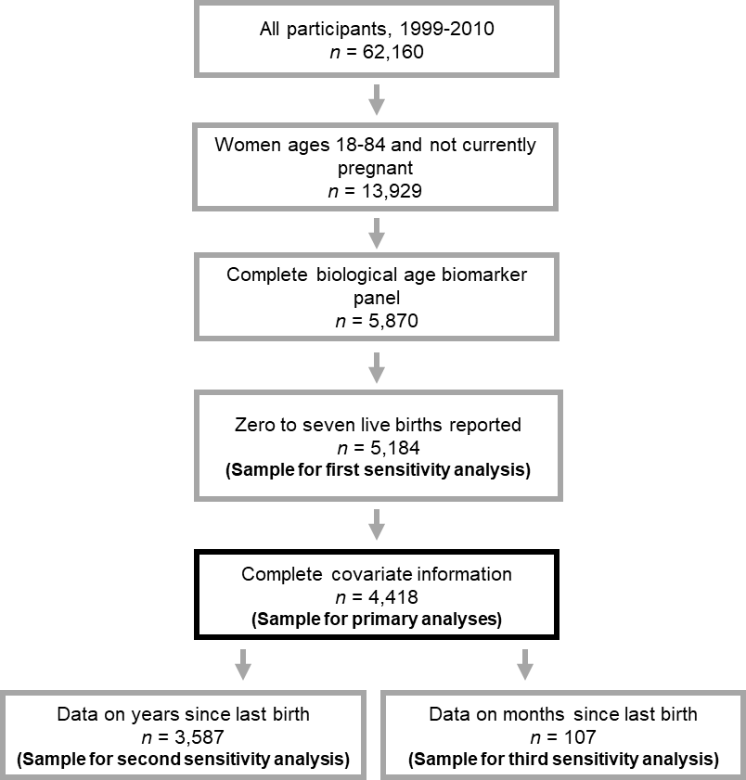

**Figure 2.**

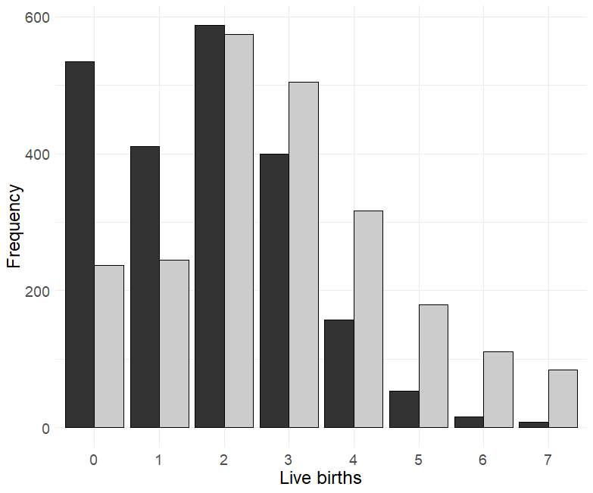

**Figure 3.**

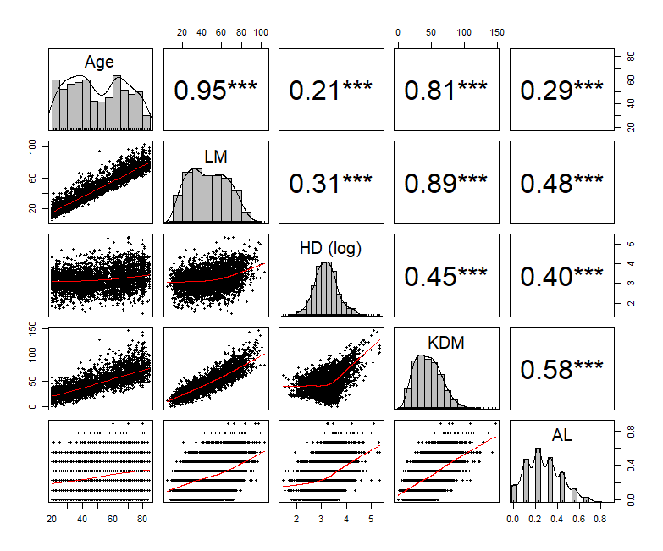

**Figure 4.**

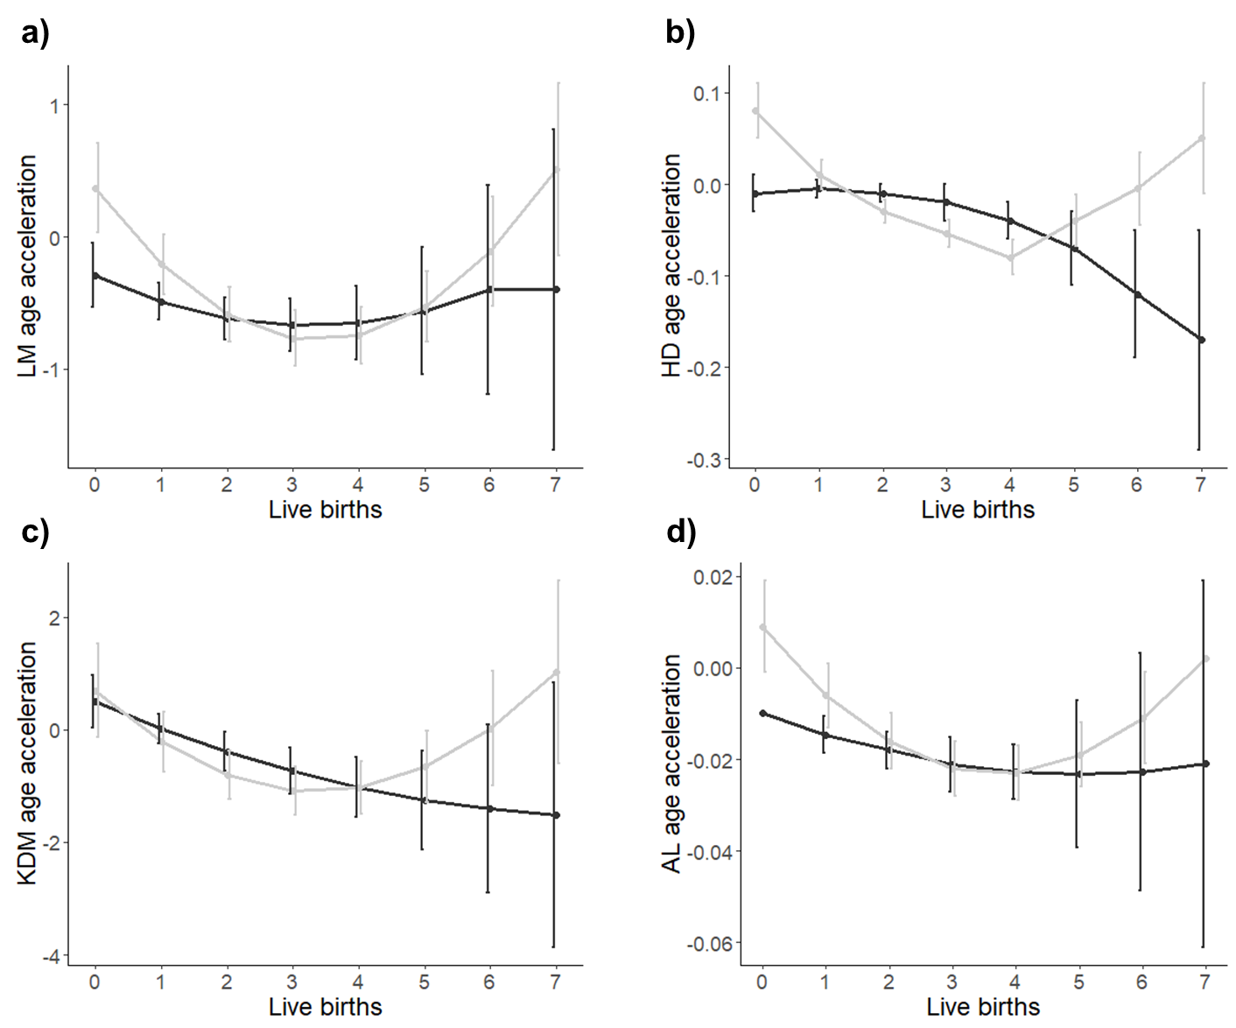

**Table 1.** Sample demographic characteristics (*n* = 4,418), National Health and Nutrition Examination Survey, 1999-2010. Means, standard errors (SE), and percentages represent nationally-representative estimates based on adjustment for complex survey design, survey nonresponse, non-coverage, and complex survey design. Unless otherwise noted, p-values reflect tests of difference via t-test or Chi-Square as appropriate.

|  |  |  |  |
| --- | --- | --- | --- |
|  | Premenopausal (n = 2,166) | Postmenopausal (n = 2,252) | p-value |
| Mean age (SE, range) | 34.34 (0.19, 20-61) | 65.66 (0.22, 41-84) | <0.001 |
| Mean BMI (SE, range) | 28.97 (0.16, 15.6-71.3) | 29.33 (0.14, 14.7-57.6) | 0.086 |
| Mean FIPR (SE, range) | 2.50 (0.03, 0-5) | 2.66 (0.03, 0-5) | <0.001 |
| Smoking (n, %) |  |  | <0.001 |
| Never | 1367 (63.1%) | 1278 (56.7% |  |
| Past | 290 (13.4%) | 659 (29.3%) |  |
| Current | 509 (23.5%) | 315 (14.0%) |  |
| Education (n, %) |  |  | <0.001 |
| Less than high school | 489 (22.6%) | 682 (30.3%) |  |
| High school or equivalent | 465 (21.5%) | 617 (27.4) |  |
| Some college or AA degree | 744 (34.3%) | 593 (26.3%) |  |
| College graduate or above | 468 (21.6%) | 360 (16.0%) |  |
| Race/ethnicity (n, %) |  |  | <0.001 |
| Non-Hispanic white | 1007 (46.5%) | 1309 (58.1%) |  |
| Non-Hispanic black | 445 (20.5%) | 396 (17.6%) |  |
| Hispanic | 626 (28.9%) | 488 (21.7%) |  |
| Other | 88 (4.1%) | 59 (2.6%) |  |
| Mean number of live births (SE, range) | 1.77 (0.03, 0-7) | 2.81 (0.04, 0-7) | <0.001 |
| Ever-parity (n, %) |  |  | <0.001 |
| Nulliparous | 534 (24.7%) | 237 (10.5%) |  |
| Parous | 1632 (75.3%) | 2015 (89.5%) |  |
| LM Biological Age | 30.32 (0.23, 4.7-81.3) | 61.92 (0.27, 26.0-103.6) | 0.002† |
| LM Biological Age acceleration |  |  |  |
| Homeostatic Dysregulation | 3.10 (0.01, 1.5-4.8) | 3.29 (0.01, 1.5-5.3) | 0.696† |
| Homeostatic Dysregulation |  |  |  |
| KDM Biological Age | 31.49 (0.26, 0.6-111.6) | 60.59 (0.35, 17.1-147.3) | <0.001† |
| KDM Biological Age acceleration |  |  |  |
| Allostatic Load | 0.23 (0.00, 0.0-0.8) | 0.32 (0.00, 0.0-0.9) | 0.307† |
| Allostatic Load acceleration |  |  |  |

† p-values from linear regression models adjusted for the following variables: chronological age, body mass index, federal income-to-poverty ratio, smoking, education, and self-identified race/ethnicity.

**Table 2.** Multiple linear regression examining the chronic and acute effects of number of live births on biological age acceleration for premenopausal women only, National Health and Nutrition Examination Survey 1999-2010. Values represent coefficient estimates and 95% confidence intervals. *Notes:* * *p* < 0.05, ** *p* < 0.01, *** *p* < 0.001; values in **bold** represent effects significant after multiple comparison correction at α = (0.05/4) = 0.0125.

|  |  |  |  |  |
| --- | --- | --- | --- | --- |
|  | **LM** | **HD (log)** | **KDM** | **AL** |
| **Primary model (*n* = 2,166)** † | | | | |
| Live births (linear) | -0.24 (-0.70, 0.22) | 0.02 (-0.03, 0.06) | -0.51 (-1.53, 0.51) | -0.01 (-0.02, 0.01) |
| Live births (quadratic) | 0.04 (-0.06, 0.13) | -0.01 (-0.02, 0.004) | 0.03 (-0.18, 0.24) | 0.001 (-0.002, 0.003) |
| **Sensitivity analysis 1 (n = 2,686)** †† | | | | |
| Live births (linear) | 0.03 (-0.46, 0.52) | 0.01 (-0.03, 0.05) | -0.24 (-1.15, 0.67) | -0.004 (-0.02, 0.01) |
| Live births (quadratic) | 0.06 (-0.04, 0.17) | -0.003 (-0.01, 0.01) | 0.05 (-0.13, 0.24) | 0.002 (-0.001, 0.01) |
| **Sensitivity analysis 2 (n = 1,617)** † | | | | |
| Live births (linear) | -0.04 (-1.66, 1.57) | 0.08 (-0.06, 0.22) | -1.34 (-4.24, 1.56) | -0.04 (-0.08, 0.01) |
| Live births (quadratic) | 0.01 (-0.26, 0.29) | -0.02 (-0.04, 0.001) | 0.10 (-0.40, 0.60) | 0.005 (-0.002, 0.01) |
| Years since last birth | 0.02 (-0.14, 0.19) | -0.01 (0.02, 0.01) | -0.004 (-0.36, 0.36) | -0.002 (-0.01, 0.003) |
| Live births (linear) x years since last live birth | 0.03 (-0.10, 0.17) | -0.001 (-0.01, 0.01) | 0.02 (-0.27, 0.32) | 0.002 (-0.003, 0.006) |
| Live births (quadratic) x years since last live birth | -0.01 (-0.03, 0.02) | 0.001 (-0.002, 0.003) | 0.006 (-0.05, 0.06) | -0.0002 (-0.0009, 0.0006) |
| **Sensitivity analysis 3 (n = 107)** † | | | | |
| Live births (linear) | -6.63 (-13.19, -0.07) * | 0.25 (-0.39, 0.90) | -2.70 (-14.83, 9.43) | -0.06 (-0.21, 0.08) |
| Live births (quadratic) | 1.15 (0.14, 2.17) * | -0.02 (-0.12, 0.08) | 0.66 (-1.49, 2.82) | 0.02 (-0.01, 0.04) |
| Months since last live birth | -1.07 (-1.81, -0.34) * | 0.05 (-0.04, 0.14) | -0.71 (-2.06, 0.65) | -0.01 (-0.02, 0.01) |
| Live births (linear) x months since last live birth | 0.60 (0.14, 1.05) * | -0.04 (-0.10, 0.02) | 0.23 (-0.72, 1.17) | -0.001 (-0.01, 0.01) |
| Live births (quadratic) x months since last live birth | -0.09 (-0.15, -0.02) * | 0.01 (-0.003, 0.014) | -0.03 (-0.18, 0.11) | 0.0003 (-0.001, 0.002) |

† Models were adjusted for the following variables: chronological age, body mass index, federal income-to-poverty ratio, smoking, education, and self-identified race/ethnicity.

†† Model was adjusted for chronological age only.

**Table 3.** Multiple linear regression examining the chronic and acute effects of number of live births on biological age acceleration for postmenopausal women only, National Health and Nutrition Examination Survey 1999-2010. Values represent coefficient estimates and 95% confidence intervals. *Notes:* * *p* < 0.05, ** *p* < 0.01, *** *p* < 0.001; values in **bold** represent effects significant after multiple comparison correction at α = (0.05/4) = 0.0125.

|  |  |  |  |  |
| --- | --- | --- | --- | --- |
|  | **LM** | **HD (log)** | **KDM** | **AL** |
| **Primary model (*n* = 2,252)** † | | | | |
| Live births (linear) | **-0.68 (-1.11, -0.25)\*\*** | **-0.07 (-0.11, -0.04)\*\*\*** | -1.07 (-2.12, -0.02)* | **-0.02 (-0.03, -0.01)\*\*** |
| Live births (quadratic) | **0.10 (0.03, 0.17)\*\*** | **0.010 (0.004, 0.02)\*\*** | 0.16 (-0.01, 0.33) | **0.002 (0.001, 0.004)\*** |
| **Sensitivity analysis 1 (n = 2,498)** †† | | | | |
| Live births (linear) | **-0.80 (-1.30, -0.30)\*\*** | **-0.08 (-0.12, -0.04)\*\*\*** | -1.10 (-2.10, -0.10)* | **-0.02 (-0.03, -0.01)\*\*** |
| Live births (quadratic) | **0.17 (0.09, 0.25)\*\*\*** | **0.013 (0.007, 0.02)\*\*\*** | **0.23 (0.08, 0.39)\*\*** | **0.004 (0.002, 0.01)\*\*\*** |
| **Sensitivity analysis 2 (n = 1.970)** † | | | | |
| Live births (linear) | -0.27 (-2.76, 2.22) | -0.21 (-0.45, 0.04) | -2.75 (-8.56, 3.06) | -0.02 (-0.10, 0.05) |
| Live births (quadratic) | 0.06 (-0.33, 0.46) | 0.03 (-0.01, 0.06) | 0.50 (-0.33, 1.32) | -0.005 (-0.005, 0.015) |
| Years since last birth | -0.01 (-0.11, 0.08) | -0.002 (-0.01, 0.01) | -0.02 (-0.32, 0.27) | 0.001 (-0.003, 0.004) |
| Live births (linear) x years since last live birth | 0.005 (-0.07, 0.08) | 0.004 (-0.002, 0.01) | 0.07 (-0.10, 0.24) | 0.0003 (-0.002, 0.002) |
| Live births (quadratic) x years since last live birth | -0.001 (-0.01, 0.01) | -0.001 (-0.002, 0.000) | -0.01 (-0.04, 0.01) | -0.0001 (-0.0004, 0.0002) |

† Models were adjusted for the following variables: chronological age, body mass index, federal income-to-poverty ratio, smoking, education, and self-identified race/ethnicity.

†† Model was adjusted for chronological age only.